Name _________________________________________________________ Date ______________ Hr _____

Activity 1.2 - What happens to energy when objects collide?

Part 4 – Motion and energy simulation

Using the simulation link on my website (christyjjh.weebly.com), explore why heavier or lighter spheres move at different speeds after a collision.

Use the following graphs to sketch the given variable changes.
- Complete a few trials of each before sketching below.
- Make sure the numbers you’re choosing register on all the graphs.

- Low mass & same speed 2. High mass & same speed

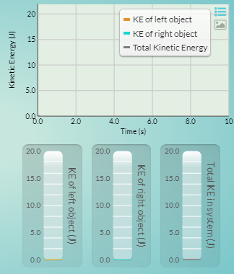
- What is the relationship between mass and kinetic energy?

- Same mass & low speed 4. Same mass & high speed

- What is the relationship between speed and kinetic energy?

- Justify your answer using evidence from the simulation.

- What pattern do you notice about the total amount of kinetic energy before and after each collision in the simulation?

- Justify your answer using evidence from the simulation.

