Name______________________________________________________Date________________Hour_______
Unit 2 - Investigation 2 – Activity 2.3
Why is lightning so much bigger than a spark from the Van de Graaff generator?

Introduction

In the reading for Activity 2.2, “Potential Energy and Fields,” you learned that it is helpful to think of potential energy as energy that is stored in a field when objects are interacting without touching. In this activity, you will evaluate factors that can affect the amount of energy that is stored in a field.

Factors that affect the potential energy of a spring

Materials
- 2 springs of different strengths

- Stretch and compress the two springs. Compare the amount of force that is needed to change each spring.

- If you were going to use a spring to launch something, what could you do to make it move faster?

- When compressed by equal amounts, which spring has more potential energy? Justify your answer.

Factors that affect magnetic potential energy
Materials
- 2 pairs of magnets (a stronger pair and a weaker pair)
- paper clip (or other small metal object)

Compare the strengths of each type of magnet by testing how difficult it is to separate the magnet from the paper clip
- Identify which magnets are stronger and which magnets are weaker. Be sure to justify your answer.

- Experiment with magnets to feel the force between different pairs of magnets at different distances. Which pair stores the most potential energy in the field? Justify your answer.

- Experiment with arrangements of pairs of magnets that attract and repel. Compare what you feel and what you think might be happening to the amount of potential energy associated with the magnetic field.

7. Remember that potential energy is stored in fields. Describe which two magnets you would use and how you would arrange them in order to have the most potential energy in the magnetic field. You can use a model to draw the arrangement.

Factors that affect potential energy in an electric field
Go to the WEEBLY CLASS WEBSITE to find the link for the COMPUTER SIMULATION
Use the simulation to explore how different factors might affect the amount of potential energy in an electric field. Be sure to test the following:
- Similar and opposite charges
- Different distances between the charges
- Amount of charge

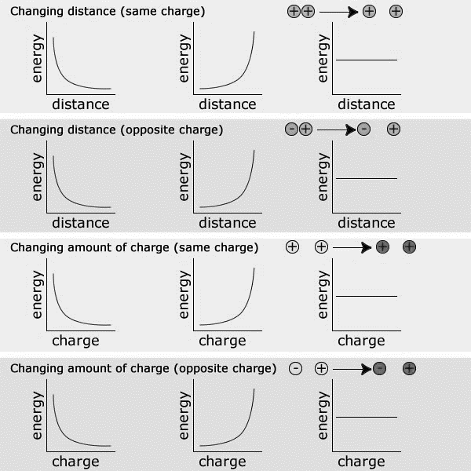
8. For each row, circle the graph that indicates how changing distance or amount of charge affects potential energy in the electrical field.
Note: For the positive and negative charges shown, darker shades of red and blue coloring indicate a greater amount of charge.

9. Using the answers to the previous question, identify all of the factors that influence the amount of potential energy that is stored in an electric field.

10. Use the ideas of energy and charge to explain why bolts of lightning are so much bigger than sparks from the Van de Graaff generator.

LINKS

COMPUTER SIMULATION: http://lab.concord.org/interactives.html#interactives/interactions/electricPE2.json

