Name_____________________________________________________________Date________________Hour_______
Unit 2 - Investigation 2 – Activity 2.4

Why do I get shocked if I am too close to the Van de Graaff generator?
In this activity, you will learn why certain arrangements of objects within a system occur more frequently than other arrangements. You will also investigate how the amount of P.E. in a system influences the position of the objects.

Introduction - You have defined factors that affect the amount of potential energy in a system. In this activity, you will investigate what happens to the potential energy of a system when objects can move freely (not held in place).

___ 1. What do you think will happen to the potential energy of a system if the objects in the system can move freely?
a. The potential energy will increase. c. The potential energy will stay the same.
b. The potential energy will decrease. d. It depends on the situation.

Dropping pencils
Materials:
- New pencils with a flat eraser at the end
Your challenge: Try to drop the pencil so that it lands standing on its eraser.
- Did your pencil land standing on its eraser? Record your observations.

COMPUTER SIMULATION #1: Charge, distance, and potential energy simulation
Go to the WEEBLY CLASS WEBSITE to find the link for the COMPUTER SIMULATION

Explore the simulation. Observe whether choosing different types of charge, amounts of charge, and distances between the particles affects the potential energy of the system.

- For one setup of the simulation, draw a stacked bar graph (see notebook entry 6) below to compare the different types of energy at the beginning and after the simulation stops running. Your graph should include potential and thermal energy.

- Provide a description by each bar on the graph above explaining what it’s showing.

- For oppositely charged objects, describe the relative position/arrangement of the two objects when the system has reached the most stable point.

- For the objects at this point, what do you notice about their potential energy?

- What would you have to change in the system for it to be most stable when the objects are in a different relative position?

- For similarly charged objects, what do you think the relative position of the two objects will be when the system has reached the most stable point?

- What is similar about the most stable point for all the different trials you did with the simulation?

- Compare your observations of dropping the pencil with your observations of the simulation. Use the idea of energy to explain at least 2 similarities & differences between the pencil activity and the simulation.

Similarities | Differences

COMPUTER SIMULATION #2 - Sparks

Go to the WEEBLY CLASS WEBSITE to find the link for the COMPUTER SIMULATION #2

This simulation illustrates the basic principle behind the formation of sparks from the Van de Graaff generator.

- Recall your observations of the actual Van de Graaff generator and discharge wand. When the Van de Graaff generator and discharge wand were close enough to each other, a spark occurred. Use the simulation, as well as what you have learned about the tendency of potential energy to decrease, to explain why you observed a spark.

- What happens to the overall charge of the surfaces of the Van de Graaff generator and discharge wand after a spark occurs? Justify your answer.

- The process that causes a spark to occur when the discharge wand is close to the Van de Graaff generator is similar to the process that causes lightning to form. Use what you have learned about the tendency of potential energy to decrease to try to explain how lightning occurs.

LINKS

COMPUTER SIMULATIONS: https://lab.concord.org/embeddable.html#interactives/interactions/electricPE3.json
https://lab.concord.org/embeddable.html#interactives/interactions/spark.json

Name_____________________________________________________________Date________________Hour_______

Revisiting phenomena
In this activity, you will use ideas of potential energy of the electric field, charge buildup, and the tendency of systems to move toward more stable states to revise your model of the pie pans and the Van de Graaff generator.
  - Add charges to the Van de Graaff images.
  - Draw energy graphs below each step of the VDG diagram to explain why the pie pans fly off the Van de Graaff generator. In your graphs, indicate the amount and type of energy for the following: 1) when the generator is turned on but before the pie pans start to fly away, 2) as the pie pans are flying through the air, and 3) after everything has stopped moving.
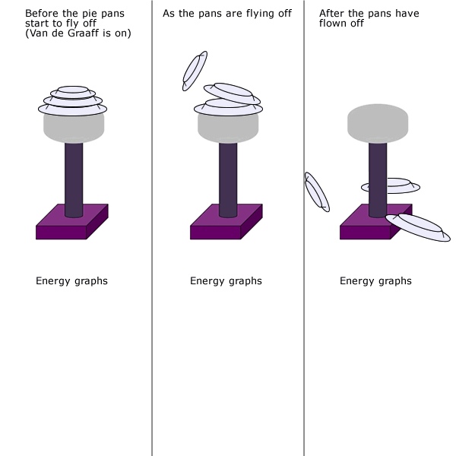
- Describe how the graphs and charges you added explain your observations of the pie pans and the VDG. Be sure to include your new ideas about energy.

Name_____________________________________________________________Date________________Hour_______
Exit Ticket - Revisiting the driving question
- While you still need to know more about what happens in an explosion to answer the driving question, you do have new information that can be used to make sense of what happens when you observe a spark. Use the ideas about energy that you have learned to write a possible explanation for how a spark might start an explosion.

Name_____________________________________________________________Date________________Hour_______
Exit Ticket - Revisiting the driving question
- While you still need to know more about what happens in an explosion to answer the driving question, you do have new information that can be used to make sense of what happens when you observe a spark. Use the ideas about energy that you have learned to write a possible explanation for how a spark might start an explosion.

